Book Group Selection Ideas
March 31, 2022 Edition

Here are some more book group selection ideas collected from our last book group meeting. Get ready to vote for our next five selections.
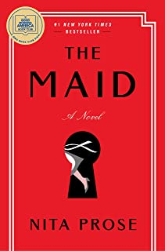
The Maid: A Novel by Nita Prose
Genre: Contemporary Fiction, Mystery.

Selling Points
Selection for Good Morning America Book Club
Group Member Suggestion

Description
Molly Gray is not like everyone else. She struggles with social skills and misreads the intentions of others. Her gran used to interpret the world for her, codifying it into simple rules that Molly could live by.
Since Gran died a few months ago, twenty-five-year-old Molly has been navigating life’s complexities all by herself. No matter—she throws herself with gusto into her work as a hotel maid, and finds comfort in the order she creates.
But Molly’s orderly life is upended the day she enters the suite of the infamous and wealthy Charles Black, only to find it in a state of disarray and Mr. Black himself dead in his bed. Before she knows what’s happening, Molly’s unusual demeanor has the police targeting her as their lead suspect. She quickly finds herself caught in a web of deception, one she has no idea how to untangle. Fortunately for Molly, friends she never knew she had unite with her in a search for clues to what really happened to Mr. Black—but will they be able to find the real killer before it’s too late?
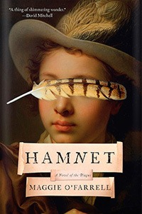
Hamnet by Maggie O’Farrell
Genre: Literary Fiction, Historical Fiction

Selling Points
National Book Critics Circle Award Winner
Group Member Suggestion.
Description
n 1580’s England, during the Black Plague a young Latin tutor falls in love with an extraordinary, eccentric young woman in this “exceptional historical novel” (The New Yorker) and best-selling winner of the Women’s Prize for Fiction.
Agnes is a wild creature who walks her family’s land with a falcon on her glove and is known throughout the countryside for her unusual gifts as a healer, understanding plants and potions better than she does people. Once she settles with her husband on Henley Street in Stratford-upon-Avon she becomes a fiercely protective mother and a steadfast, centrifugal force in the life of her young husband, whose career on the London stage is taking off when his beloved young son succumbs to sudden fever.
A luminous portrait of a marriage, a shattering evocation of a family ravaged by grief and loss, and a tender and unforgettable re-imagining of a boy whose life has been all but forgotten, and whose name was given to one of the most celebrated plays of all time, Hamnet is mesmerizing, seductive, impossible to put down—a magnificent leap forward from one of our most gifted novelists.

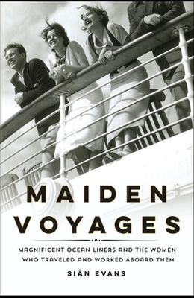
Maiden Voyages: Magnificent Ocean Liners and the Women Who Traveled and Worked Aboard Them by Sian Evans
Genre: Nonfiction, History

Selling Points
Group Member Suggestion.

Description
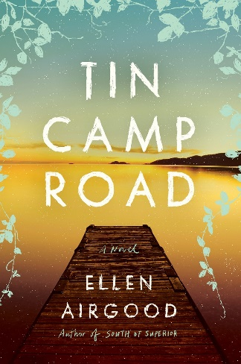
Maiden Voyages is a fascinating portrait of the era, the ships themselves, and these women as they crossed the Atlantic. The ocean liner was a microcosm of contemporary society, divided by class: from the luxury of the upper deck, playground for the rich and famous, to the cramped conditions of steerage or third class travel. In first class you’ll meet A-listers like Marlene Dietrich, Wallis Simpson, and Josephine Baker; the second class carried a new generation of professional and independent women, like pioneering interior designer Sibyl Colefax. Down in steerage, you’ll follow the journey of émigré Maria Riffelmacher as she escapes poverty in Europe. Bustling between decks is a crew of female workers, including Violet “The Unsinkable Stewardess” Jessop, who survived the Titanic disaster.
Tin Camp Road by Ellen Airgood
Genre: Contemporary Fiction, Michigan Author
Selling Points
Recently Featured by National Writers Series
Potential for an Author Visit
Renee is currently reading. Will give her review at April meeting.
Description
Set against the wide-open beauty of Michigan’s Upper Peninsula, Tin Camp Road is a wise, big-hearted novel from Ellen Airgood in which a young single mother and her ten-year-old daughter stand up to the trials of rural poverty and find the community they need in order to survive.
One otherwise normal afternoon, their landlord decides to evict them in favor of a more profitable summer rental, and, without any warning, they are pushed farther to the margins. Suddenly it feels like the independence that has defined them is a liability. And when a dangerous incident threatens to separate them, Laurel and Skye must forever choose–will they leave the place they love and the hardscrabble life they’ve built to move closer to civilization, or risk everything to embrace the emptiness and wildness that has defined them?

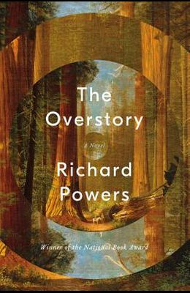
The Overstory by Richard Powers

Genre: Contemporary Fiction, Literary

Selling Points

Winner of the 2019 Pulitzer Prize in Fiction

Group Member suggestion

Description

The Overstory, winner of the Pulitzer Prize in Fiction, is a sweeping, impassioned work of activism and resistance that is also a stunning evocation of—and paean to—the natural world. From the roots to the crown and back to the seeds, Richard Powers’s twelfth novel unfolds in concentric rings of interlocking fables that range from antebellum New York to the late twentieth-century Timber Wars of the Pacific Northwest and beyond. There is a world alongside ours—vast, slow, interconnected, resourceful, magnificently inventive, and almost invisible to us. This is the story of a handful of people who learn how to see that world and who are drawn up into its unfolding catastrophe.

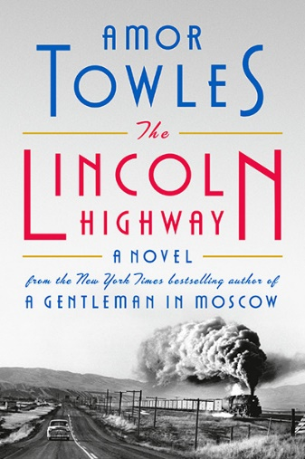
Lincoln Highway by Amor Towles

Genre: Contemporary Fiction

Selling Points

Popular Besteller (may be hard to get copies)

Member Suggestion

Description
In June, 1954, eighteen-year-old Emmett Watson is driven home to Nebraska by the warden of the juvenile work farm where he has just served fifteen months for involuntary manslaughter. His mother long gone, his father recently deceased, and the family farm foreclosed upon by the bank, Emmett’s intention is to pick up his eight-year-old brother, Billy, and head to California where they can start their lives anew.
But when the warden drives away, Emmett discovers that two friends from the work farm—the wily, charismatic Duchess and earnest, offbeat Woolly—have stowed away in the trunk of the warden’s car. Together, they have hatched an altogether different plan for Emmett’s future, one that will take the four of them on a fateful journey in the opposite direction to the city of New York.
Spanning ten days and told from multiple points of view, Towles’s third novel is a multilayered tale of misadventure and self-discovery, populated by an eclectic cast of characters, from drifters who make their home riding the rails and larger-than-life vaudevillians to the aristocrats of the Upper East Side. An absorbing, exhilarating ride, The Lincoln Highway is a novel as vivid, sweeping, and moving as readers have come to expect from Towles’s work.
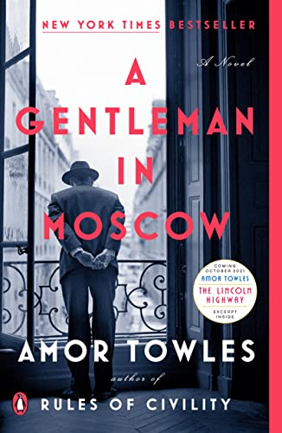

A Gentleman in Moscow by Amor Towles

Genre: Contemporary Fiction

Selling Points

May be easier to find copie of this older book by Towles.

Member Reccomendation

Description

A beautifully transporting novel about a man who is ordered to spend the rest of his life inside a luxury hotel
In 1922, Count Alexander Rostov is deemed an unrepentant aristocrat by a Bolshevik tribunal, and is sentenced to house arrest in the Metropol, a grand hotel across the street from the Kremlin. Rostov, an indomitable man of erudition and wit, has never worked a day in his life, and must now live in an attic room while some of the most tumultuous decades in Russian history are unfolding outside the hotel’s doors. Unexpectedly, his reduced circumstances provide him entry into a much larger world of emotional discovery.
Brimming with humor, a glittering cast of characters, and one beautifully rendered scene after another, this singular novel casts a spell as it relates the count’s endeavor to gain a deeper understanding of what it means to be a man of purpose.

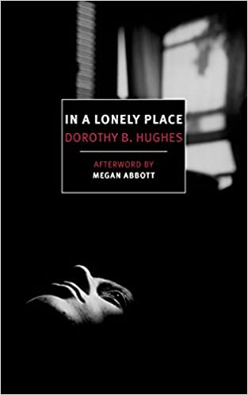
In a Lonely Place by Dorothy B. Hughes

Genre: Modern Fiction, Film Noir

Selling Points

Classic Detective Noir by female author

Basis of 1950 film

From Renee’s to be read list.

Description

A classic California noir with a feminist twist, this prescient 1947 novel exposed misogyny in post-World War II American society, making it far ahead of its time.
Los Angeles in the late 1940s is a city of promise and prosperity, but not for former fighter pilot Dix Steele. To his mind nothing has come close to matching “that feeling of power and exhilaration and freedom that came with loneness in the sky.” He prowls the foggy city night—bus stops and stretches of darkened beaches and movie houses just emptying out—seeking solitary young women. His funds are running out and his frustrations are growing. Where is the good life he was promised? Why does he always get a raw deal? Then he hooks up with his old Air Corps buddy Brub, now working for the LAPD, who just happens to be on the trail of the strangler who’s been terrorizing the women of the city for months...
Written with controlled elegance, Dorothy B. Hughes’s tense novel is at once an early indictment of a truly toxic masculinity and a twisty page-turner with a surprisingly feminist resolution. A classic of golden age noir, In a Lonely Place also inspired Nicholas Ray’s 1950 film of the same name, starring Humphrey Bogart.

